Classes of Address Exercise Questions

[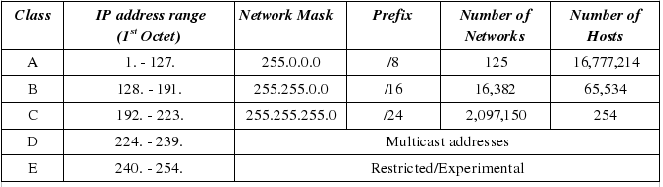](https://www.google.com/url?sa=i&rct=j&q=&esrc=s&source=images&cd=&cad=rja&uact=8&ved=0ahUKEwj2mY3Ys6PPAhVi5YMKHXRDCFMQjRwIBw&url=https%3A%2F%2Fsites.google.com%2Fsite%2Ftvcccis101js200085%2Fip-subnetmask&psig=AFQjCNFa02bB4B8CIoWgTPhFkXatZ-PTsA&ust=1474648412568281)

1. Which of the following is a Class C IP address?
   1. 10.10.14.118
   2. 135.23.112.57
   3. 191.200.199.199
   4. 204.67.118.54
   5. None of the Above
2. True or False: An RFC 1918 IP address can communicate directly to external computers via the internet.
3. From the list below, identify the class using the IP address.
   * 10110001.11101001.01111001.0101010 _________
   * 10.250.1.1 _________
   * 230.230.45.58 _________
   * 11010010.01111111.10011001.11111111 _________
4. From the list below, identify the private class using the IP address.
   1. 192.168.255.163 _________
   2. 10.0.16.160 _________
   3. 172.16.1.45 _________